**Part 1 Marking Key:**

**½ mark per box – students can either do feedback loop for too much or too little hormone.**

|  |  |  |  |  |  |  |
| --- | --- | --- | --- | --- | --- | --- |
| **Hormone** | **Stimulus** | **Receptor** | **Modulator** | **Effector** | **Response** | **Feedback** |
| **Thyroxine** | Decreased thyroxine levels in blood/ temp/metabolism | Receptors in hypothalamus | Hypothalamus signals for pituitary gland to release thyroid stimulating hormone | Thyroid | Thyroid produces more thyroxine, which increases metabolism | Increased thyroxine levels in blood/ temp/metabolism |
| Increased thyroxine levels in blood/ temp/metabolism | Decreased TSH | Less thyroxine, decreased metabolism | Decreased thyroxine levels in blood/ temp/metabolism |
| **Cortisol** | Decrease in blood sugar | Receptors in hypothalamus | Hypothalamus signals for pituitary gland to release more ACTH | Adrenal Gland (Cortex) | More cortisol secreted by adrenal gland | Increase in blood sugar |
| Increase in blood sugar | Hypothalamus signals for pituitary gland to release less ACTH | Less cortisol secreted by adrenal gland | Decrease in blood sugar |
| **Growth Hormone** | Sleep/ Stress/ Exercise / low blood glucose levels | Receptors in hypothalamus | Hypothalamus signals for pituitary to release GH | Pituitary Gland | Pituitary gland secretes more GH | Repair of cells and muscles / increased blood glucose / increased metabolism |
| Increased GH in blood | Hypothalamus stops signals for pituitary to release GH | Pituitary gland secretes less GH | Stop repair of cells and muscles / decreased blood glucose / decreased metabolism |
| **Adrenaline** | Stressful Event | Receptors in Hypothalamus | Nerve impulses sent from hypothalamus to adrenal medulla | Adrenal Gland (medulla) | Adrenal medulla secretes adrenaline | Body can respond to stressful event; increased metabolism, increased blood glucose, increased heart rate |
| Stressful event finished | Nerve impulses stop sending from hypothalamus to adrenal medulla | Adrenal medulla secretes less adrenaline | Decreased metabolism, decreased blood glucose, decreased heart rate |

**/12**

**1 mark per box.** *Students must have most of the information in the box to get the mark.*

|  |  |  |  |  |  |
| --- | --- | --- | --- | --- | --- |
| **Hormone** | **Dysfunction** | **Cause** | **Symptoms** | **Treatment** | |
| **Non-hormonal treatment** | **Hormone Replacement Therapy** |
| **Thyroxine** | **Hypothyroidism** | - Lack of iodine in diet  -Hashimoto’s (destruction of thyroid)  -Part of thyroid removed in surgery 🡪  Too little thyroxine in diet | Any 3 symptoms:  Goitre, Fatigue, Weight gain, Hard to warm up, Dry skin, Loss of hair, Cramps, Constipation, Puffy eyes | Increase iodine in diet | Synthetic thyroxine to maintain steady thyroxine levels |
| **Hyperthyroidism** | -Inflammation of thyroid,  -Grave’s Disease,  🡪  Too much thyroxine in diet | Any 3 symptoms:  Fatigue, Weight loss, Tremors, Anxiety, Rapid heart beat, Mood swings | Removal of part of the thyroid  Radioactive iodine | - Antithyroid medications interfere with production of thyroxine  - Beta blockers effect how thyroxine affects body |
| **Cortisol** | **Cushing’s Disease** | -Body naturally produces more cortisol  – pituitary tumor  -genetic  -use of oral corticosteroid medication | Any 3 symptoms:  Rapid weight gain with slender arms and legs, Flushed face, High blood pressure, Osteoporosis, Skin changes, Muscle weakness, Mood swings, Increased thirst and urination | -Surgery to remove if tumour is causing it  -Radiation therapy | Reduce use of synthetic hydrocortisone |
| **Addison’s Disease** | Autoimmune disease where immune system destroys cells of adrenal cortex | Any 3 symptoms:  Fatigue, Dizziness, Weight loss, Muscle weakness, Mood changes, Darkening of skin | Future 🡪 steam cell replacement therapy to replace lost adrenal cells | - Hydrocortisone tablets (cortisol replacement)  Fludrocortisone tablets – Aldosterone replacement |
| **Growth Hormone** | **Growth Hormone Deficiency** | -a tumour in the hypothalamus or pituitary  -head trauma  -radiation therapy for [cancers](http://www.childrenshospital.org/conditions-and-treatments/conditions/c/cancer) - histiocytosis -an autoimmune condition (lymphocytic hypophysitis) | Any 3 symptoms:  immature appearance compared to peers, a chubby body build, a prominent forehead, an underdeveloped bridge of the nose | -Removal of tumour if that is cause  -Psychological therapy as children very prone to bullying  Regular exercise  -Future 🡪 stem cell replacement therapy | Synthetic growth hormone |
| **Acromegaly** | Overproduction og GH in adulthood  -Tumour on pituitary gland  -Random tumor that produces GHRH | Any 3 symptoms:  enlarged hands/feet, protruding lower jaw and brow, enlarged nose, thickened lips, wider space between teeth | -Removal of a tumour  -Radiation therapy | No HRT – but injection of drugs that block GH from being made or released |

**/24**

**Part 2 Marking Key – Poster**

|  |  |  |  |  |  |  |  |  |
| --- | --- | --- | --- | --- | --- | --- | --- | --- |
| **Question** | **A** | | **B** | | **C** | | **D** | |
| **4** | **3.5** | **3** | **2.5** | **2** | **1.5** | **1** | **0.5** |
| How the hormone that causes your dysfunction is normally regulated | Uses appropriate scientific language, conventions and clearly labelled diagrams to correctly explain concepts. | | Uses scientific language, conventions and labelled diagrams to explain concepts. | | Uses some scientific language, conventions and supporting diagrams to describe concepts. | | Uses everyday language and provides simple diagrams to describe some concepts. | |
|  | **4** | **3.5** | **3** | **2.5** | **2** | **1.5** | **1** | **0.5** |
| What homeostasis is and how your disorder disrupts homeostasis | Applies concepts and scientific knowledge to describe structures and systems and explain processes, in detail. | | Applies concepts and scientific knowledge to describe structures and systems and explain some processes. | | Describes some structures, systems and processes in a general way. | | Identifies some structures, systems and processes. | |
|  | **4** | **3.5** | **3** | **2.5** | **2** | **1.5** | **1** | **0.5** |
| The causes, symptoms and treatment options for your disorder | Communicates information and concepts logically, using correct scientific language, conventions and representations. | | Communicates information and concepts generally using scientific language and representations. Makes some errors in the use of conventions. | | Communicates information and concepts, without detail, using some scientific language and conventions. | | Communicates information using everyday language with frequent errors in the use of conventions. | |
|  | **4** | **3.5** | **3** | **2.5** | **2** | **1.5** | **1** | **0.5** |
| An evaluation of whether you believe that Australians should be more worried about your chosen disorder than diabetes | Analyses issues and presents clear and logical arguments or reasons which are supported by evidence.  Selects and assesses the relevance of scientific information from a variety of sources to support a point of view. | | Analyses issues and presents arguments or statements that are sometimes well supported by evidence.  Selects scientific information from a variety of sources to support a point of view. | | Discusses issues and presents general statements supported by limited evidence.  Selects limited scientific information to support a point of view. | | Discusses issues and presents general statements that may include incomplete or incorrect information.  Makes little use of evidence to support a point of view. | |

**/16**

**General Comment:**

___________________________________________________________________________

___________________________________________________________________________

___________________________________________________________________________

___________________________________________________________________________

**Part 3 Marking Key**

**/25**

1. With the aid of a diagram, describe how a negative feedback loop works to maintain your body within tolerance limits.

|  |  |
| --- | --- |
| **Description** | **Mark** |
| Diagram is neat and cyclical | 1 |
| Receptor + explanation | 1 |
| Modulator + explanation | 1 |
| Effector + Explanation | 1 |
| Response + Explanation | 1 |
| Feedback + Explanation | 1 |
| **TOTAL** | **6** |

1. Your Aunt Mildred has been taking medication for Hypothyroidism.
2. State which hormone is not being kept in balance.

|  |  |
| --- | --- |
| **Description** | **Mark** |
| Hormone:  Thyroxine | 1 |
| **TOTAL** | **1** |

(b) State four symptoms of the condition.

|  |  |
| --- | --- |
| **Description** | **Mark** |
| ½ mark each:  Fatigue, intolerance to cold, low heart rate, weighloss, etc | 1-2 |
| **TOTAL** | **2** |

1. Explain how the hormone is regulated when its levels become too high.

|  |  |
| --- | --- |
| **Description** | **Mark** |
| * Thyroxine level (or body temp or metabolism) detected * Hypothalamus stops secreting releasing hormone/stops signalling to pituitary * Causes pituitary to stop releasing TSH * Thyroid stops secreting thyroxine | 1-4 |
| **TOTAL** | **4** |

1. Describe why this is considered a negative feedback loop

|  |  |
| --- | --- |
| **Description** | **Mark** |
| Because the response reduces the original stimulus | 1 |
| **TOTAL** | **1** |

1. Describe how hormone replacement therapy/medications can be used to treat the condition.

|  |  |
| --- | --- |
| **Description** | **Mark** |
| Synthetic version of hormone given (levothyroxine) | 1 |
| Acts same as natural thyroxine | 1 |
| Reduces symptoms of hypothyroidism | 1 |
| **TOTAL** | **3** |

1. Explain how cortisol increases metabolism.

|  |  |
| --- | --- |
| **Description** | **Mark** |
| Increases blood glucose levels | 1 |
| Increases breakdown of glycogen to glucose | 1 |
| Increases breakdown of proteins and fats to glucose | 1 |
| **TOTAL** | **3** |

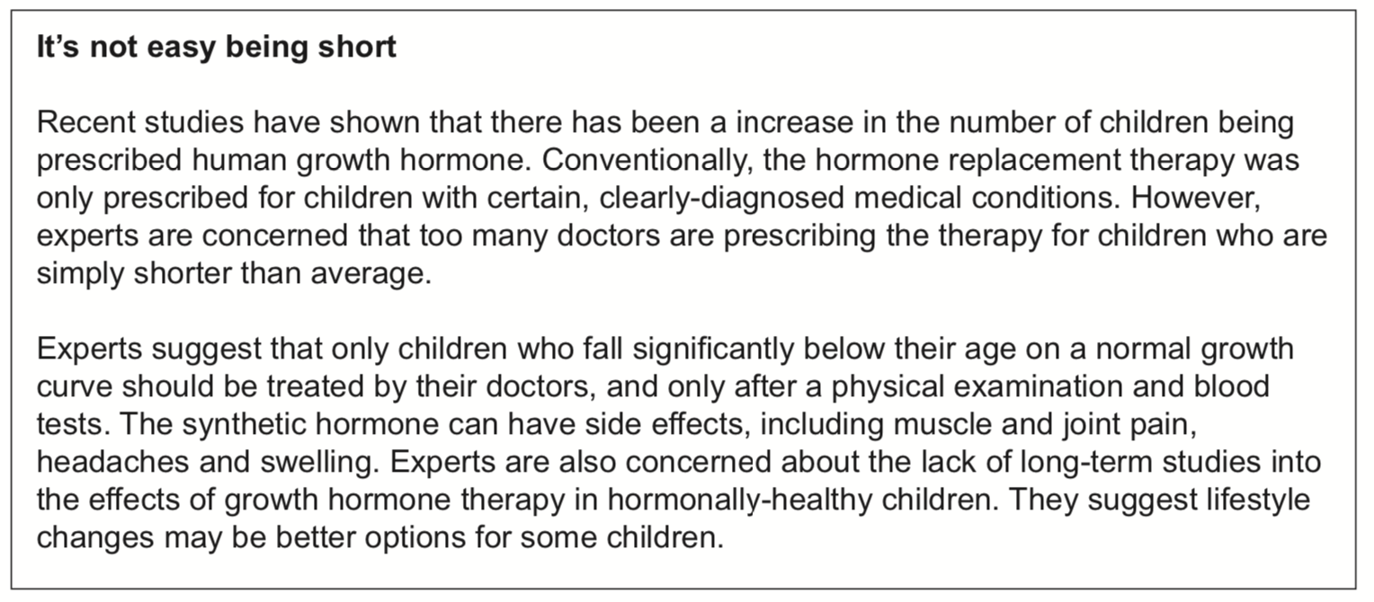

1. What is a *synthetic* hormone and why might it be needed?

|  |  |
| --- | --- |
| **Description** | **Mark** |
| Man-made/artificial hormone | 1 |
| If they fail to make GH themselves | 1 |
| **TOTAL** | **2** |

1. Observe the advertisement below, which claims to help you to grow taller, later in your life. Using your understanding of the endocrine system, explain why this advertisement is misleading

|  |  |
| --- | --- |
| **Description** | **Mark** |
| Growth is regulated by hormones | 1 |
| Main way of growing taller is to increase GH secretion when young | 1 |
| Once you’re an adult, extra GH would cause acromegaly and not actually make you taller/ any reasonable point | 1 |
| **TOTAL** | **3** |

